`

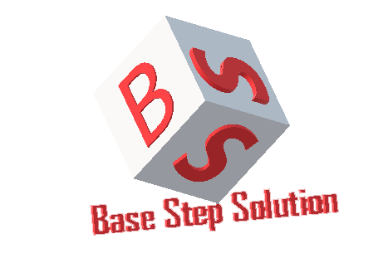

Meeting Minutes

Van Lang Admissions

# Revision Table

|  |  |  |  |
| --- | --- | --- | --- |
| Author | Date | Reason for changes | Version |
| Khoi Nguyen | 01/11/2016 | Initial Document | 1.0 |

Table of Contents

Revision Table 1

I. Purpose 3

II. Participant in meeting 3

III. Content of meeting 3

IV. To do task 4

|  |  |  |  |  |  |
| --- | --- | --- | --- | --- | --- |
| **Writer:** | Khởi Nguyễn | **Location:** | Room 701C | | |
| **Date:** | 01/11/2016 | **Start:** | 9h30 | **Finish:** | 10h30 |

# Purpose

* Ask some questions to collect requirement clearly
* Review the analysis functions

# participant in meeting

Customer : Lecturer Nguyễn Thế Quang

Team Capston:

* Nguyễn Thái Hiền
* Nguyễn Hoàng Anh Tài
* Đoàn Anh Minh
* Trần Xuân Hải
* Nguyễn Anh Khởi
* Nguyễn Xuân Thái Hiền

# Content of meeting

- Unclear about functions

- Unclear about devide level of fuction

- Data divided into 2 types : approval and without approval

- Divided by functionality rather than by categories

- The main functions can be :

+ Manage News

+ Manage Categories

+ Manage Accounts

+ Manage Decentralization

- Need have a form of each activities

# To do task

* Analysis requirement

---- *** ----